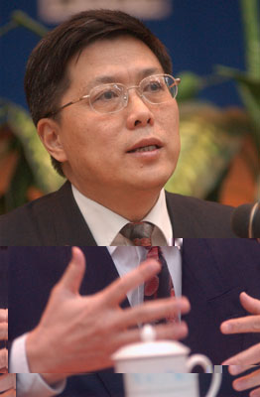

汤敏
中国经济50人论坛成员。
国务院参事，友成企业家扶贫基金会常务副理事长。
1982年毕业于武汉大学数学系，留校后在武汉大学经济管理系任教；1984年赴美国伊里诺伊大学(University of Illinois at Urban Champaign)经济系学习；1989年获博士学位后被亚洲开发银行经济发展研究中心聘为经济学家，负责东亚经济、区域间经济合作、亚洲债务、亚洲金融市场方面的研究；2000年调到亚洲开发银行驻中国代表处任首席经济学家；2007年任中国发展研究基金会副秘书长。中国人民银行研究生部部务委员会副主席。2010年12月任友成企业家扶贫基金会常务副理事长，友成大学（筹）校长。 中央党校、北京大学、武汉大学、暨南大学兼职教授，兼职教授、北京市、广州市政府金融顾问团顾问，欧美同学会商会理事等。
主要研究领域和著作：宏观经济分析,区域间经济合作、经济发展战略和国际金融业务,著有《亚洲成长三角区——区域间经济合作的一种新形式》(1994年牛津出版社出版)、《印度尼西亚—马来西亚—泰国成长三角区—理论与实践》(1996年亚洲开发银行出版社出版)、《现代经济学前沿专题》一、二、三集 (1989年，1992年，1996年商务出版社出版)，以及亚洲、中国宏观经济、部门经济、金融改革及教育改革等方面的论文百余篇。

TANG Min

Mr. Tang Min graduated from Wuhan University in 1982, and went to study in the Department of Economics, University of Illinois at Urban Champaign, US in 1984. After being awarded P.H.D degree in 1989, he joined the Development Research Center, Asian Development Bank, in charge of East Asian Economic Affairs, Regional Economic Cooperation, Asian Debts and Asian Financial Market, etc. In 2000, he was appointed as the Chief Economist in Resident Mission of Asian Development Bank in China. He was appointed as Deputy Secretary General of China Development Research Foundation of the Development Research Center of the State Council in 2007. Since December of 2010, he became the Executive Vice Chairperson of China Social Entrepreneur Foundation and the President of Youchange New Philanthropy University. Also he is a Vice Chairman of Graduate School of the People’s Bank of China. Adjunct Professor at Peking University, Wuhan University and Jinan University; Financial Advisor to Beijing Municipal Government and Guanzhou City Government; Member of Chinese Economists 50; Director of Chamber of Commerce of Western Returned Scholars Association of China.

Mr. Tang’s researches focus on macroeconomic analysis, regional economic cooperation, economic development strategies, and international finance, etc. Some of his books: Asian Growth Delta: a New Approach of Regional Economic Cooperation (Oxford University Press, 1994), The Growth Delta of Indonesia, Malaysia, and Thailand: Theories and Practices (Asian Development Bank Press, 1996), Special Topics of Frontier of Modern Economics: Book I, II, III (China Commerce and Trade Press, 1989, 1992, 1996). Mr. Tang also published more than 100 academic papers on Asian economies, China’s macroeconomic sectors, sector economics, financial reforms, and educational reforms in China, etc.

